

**THE UNIVERSITY OF BUEA**

**FACULTY OF ENGINEERING AND TECHNOLOGY**

**DEPARTMENT OF COMPUTER ENGINEERING**

**CEF 440: INTERNET PROGRAMMING AND MOBILE PROGRAMMING**

**Group 22**

**REQUIREMENTS GATHERING**

**Task 2**

|  |  |  |
| --- | --- | --- |
| **Name** | **Matricule** | **Option** |
| 1. Enow Myke-Austine Eta | FE21A183 | Software |
| 1. Mokfembam Fabrice Kongnyuy | FE21A240 | Software |
| 1. Ndangoh Boris Bobga | FE19A072 | Network |
| 1. Ndong Henry Ndang | FE21A248 | Software |
| 1. Niba Verine Kajock | FE21A267 | Network |
| 1. Takem Jim-Rawlings E. | FE21A309 | Software |

**COURSE INSTRUCTOR: Dr. Nkemeni Valery**

Contents

1. INTRODUCTION 3

2. REQUIREMENTS GATHERING FROM EXISTING DOCUMENTATION 3

2.1 Literature Review: 3

2.1 Preparedness 3

2.2 Response 3

2.3 Recovery 3

2.4 Mitigation 4

3. STAKEHOLDER IDENTIFICATION 5

3.1 Citizens 5

3.2 Emergency Responders (Firefighters, Police, Medical Personnel, Search and Rescue Teams) 5

3.3 Government Agencies (National Disaster Management Agency (NDMA), Ministry of Public Health, Local authorities) 5

3.4 Non-Governmental Organizations (NGOs) (Red Cross/Crescent Society, International aid organizations) 6

3.5 Media (News outlets, radio stations) 6

4. DATA COLLECTION 7

4.1 Methods: 7

4.1.1 Web-Based Survey 7

4.1.1.1 Survey Design: 7

4.1.1.2 Data Collection Process: 10

4.1.1.3 Sample Size and Demographics: 10

4.1.1.4 Data Security and Confidentiality: 10

4.1.2 Citizen Interviews 10

4.1.2.1 Data Collection Process: 10

4.1.2.2 Data Security and Confidentiality: 10

4.1.3 Document Review 10

4.1.3.1 Data Collection Process: 11

4.1.3.2 Sample Size and Demographics: 11

4.1.3.3 Data Security and Confidentiality: 11

5. BUSINESS REQUIREMENTS 11

5.1 Real-Time Alerting and Notification 12

5.3 Incident Reporting and Coordinated Response 12

5.6 Compliance and Security 12

6 FUNCTIONAL REQUIREMENTS 12

6.1 User Registration and Authentication 13

6.2 Real-Time Alerts and Notifications 13

6.3 Incident Reporting 13

6.4 Emergency Resource Access 13

6.5 Communication with Authorities 13

6.6 Geospatial Data Integration 13

6.7 Community Engagement Features 13

6.8 Data Privacy and Security 13

6.9 Offline Functionality 13

6.10 Multilingual Support 13

6.11 User Feedback and Support 13

7 NON-FUNCTIONAL REQUIREMENTS 13

7.1 Usability 13

7.2 Performance 13

7.3 Security 13

7.5 Scalability 14

7.6 Maintainability 14

7.7 Accessibility 14

8 REQUIREMENTS DOCUMENTATION 14

9 MANAGING REQUIREMENT CHANGES 14

9.1 Change Request Submission 14

9.2 Communication and Dissemination 14

9.3 Ongoing Monitoring and Evaluation 15

10 REFERENCES 15

# INTRODUCTION

In the wake of the growing frequency and intensity of natural disasters around the world, effective disaster management has become a critical priority for governments, emergency services, and communities. To develop a comprehensive disaster management strategy, it is essential to thoroughly understand the requirements and needs of all stakeholders involved.

This report presents the findings from a requirements gathering exercise focused on improving disaster preparedness, response, and recovery capabilities. The goal was to identify the key needs, challenges, and opportunities across various aspects of disaster management, including early warning systems, evacuation planning, emergency supplies and logistics, search and rescue operations, sheltering and housing, and long-term recovery efforts.

Requirement gathering is the process of collecting information about what the stakeholders want to achieve. It is a vital step in the software development life cycle. This task ensures there is clarity in the project and ease in its development as all other processes such as the requirement analysis or system design is dependent on what requirements are gathered.

To carry out this comprehensive requirements gathering initiative, the project team followed a structured approach consisting of the following key steps:

# REQUIREMENTS GATHERING FROM EXISTING DOCUMENTATION

A disaster management system is a comprehensive framework or set of processes, policies, and procedures that are designed to help organizations and communities prepare for, respond to, and recover from disasters. It provides a structured approach to managing all aspects of disaster management, from prevention and mitigation to response and recovery.

## 2.1 Literature Review:

Traditional methods of disaster management are based on indigenous knowledge and practices that have been passed down from generation to generation. Traditional disaster management primarily relies on manual processes and often involves the following steps:

* 1. Preparedness:
* Develop disaster plans and procedures
* Conduct training and drills
* Stockpile supplies and resources
* Identify vulnerable areas and populations
  1. Response:
* Activate emergency response teams
* Assess the situation and needs
* Provide immediate assistance to affected communities
* Coordinate with relevant authorities and organizations
  1. Recovery:
* Restore essential services and infrastructure
* Support affected individuals and communities
* Conduct damage assessments
* Develop long-term recovery plans
  1. Mitigation:
* Identify and reduce risks before disasters occur
* Implement policies and measures to lessen the impact of disasters
* Raise awareness about disaster prevention
* Invest in infrastructure resilience

The traditional method of disaster management is however due to lack of real time data to create awareness of possible occurring event and as a result, early warning or alert systems are not being utilized which would have improve the disaster management process. Another key limitation to the traditional methods for disaster management is the drawback in communication and collaboration among stakeholders involved as well as the users.

A mobile based application for disaster management utilizes technology to enhance and streamline the traditional disaster management process. Key features of such an application may include:

1. **Real-time data collection and analysis:** Collects and analyzes data from various sources (e.g., sensors, social media, satellite imagery) to provide real-time situational awareness during disasters
2. **Early warning systems**: Monitors data to issue early warnings and alerts, enabling timely evacuation and response.
3. **Resource management**: Tracks and manages available resources (e.g., personnel, equipment, supplies) to optimize their allocation during response and recovery efforts.
4. **Communication and coordination**: Facilitates communication between emergency responders, government agencies, and affected communities, ensuring timely information sharing and coordination.
5. **Damage assessment**: Uses technology (e.g., drones, satellite imagery) to conduct rapid and accurate damage assessments, aiding in recovery planning and resource allocation.
6. **Public education and preparedness**: Provides educational resources and tools to raise awareness about disaster preparedness and risk reduction measures.

Therefore, with a mobile based application for disaster management, we can improve the disaster recovery management system through;

* Improved situational awareness through real-time data
* Faster and more accurate response due to early warning systems
* Optimized resource management and coordination
* Enhanced communication and collaboration
* More efficient damage assessment and recovery planning
* Increased public awareness and preparedness

While disaster management applications offer significant benefits, they are not intended to replace traditional disaster management methods but rather to complement and enhance them. By leveraging technology, these applications can improve the efficiency, effectiveness, and coordination of disaster management efforts.

Based on existing mobile applications for disaster recovery management, some loopholes have been identified as many of the applications focus on managing a single natural or manmade disaster such as fire, or earthquake or landslide. Some of these applications are meant only for sending out warning alerts and others do not have any communication channels for collaboration between stakeholders, users and emergency responders as well as volunteers. Also, none of the existing applications target all four phases in disaster management. Therefore, in this project, we aim to overcome these shortcomings by designing a system that will involve all four phases in the disaster management life cycle, give out timely alerts and provide a communication channel for easy collaboration and so on.

# STAKEHOLDER IDENTIFICATION

Stakeholders are individuals, groups, or organizations that have an interest, involvement, or concern in the project's success or failure. Stakeholders can have a direct or indirect influence on the project's objectives, outcomes, and deliverables. An effective disaster management system requires a collaborative effort from various stakeholders. Here’s a breakdown of key stakeholder groups for our disaster management system, outlining their roles throughout the disaster management cycle:

* 1. Citizens:

1. **Preparedness**:
2. Stay informed about disaster risks (e.g., landslides, floods)
3. Participate in drills and preparedness training
4. Take mitigation measures around homes (e.g., clear drainage ditches, secure loose objects)
5. **Mitigation**:
6. Participate in community-based mitigation projects (e.g., planting trees to prevent erosion)
7. Advocate for stricter building codes in high-risk areas
8. **Response**:
9. Follow evacuation orders promptly
10. Seek shelter in designated locations
11. Report incidents to authorities.
12. **Recovery**:
13. Assist with cleanup efforts
14. Access recovery resources (shelters, food, water)
    1. Emergency Responders (Firefighters, Police, Medical Personnel, Search and Rescue Teams)**:**
15. **Preparedness**:
16. Train for various disaster scenarios
17. Maintain equipment and supplies
18. Participate in public education on hazard mitigation
19. **Mitigation**:
20. Conduct hazard assessments and identify high-risk areas
21. Participate in mock disaster drills
22. **Response**:
23. Conduct search and rescue operations
24. Provide medical aid to injured population
25. Assess damage to infrastructure and property
26. **Recovery**:
27. Support ongoing search and rescue efforts
28. Assist with infrastructure repair
    1. Government Agencies (National Disaster Management Agency (NDMA), Ministry of Public Health, Local authorities)**:**
29. **Preparedness**:
30. Develop comprehensive disaster management plans
31. Conduct risk assessments to identify vulnerable areas
32. Organize public education campaigns on preparedness measures
33. Implement mitigation projects (e.g., building seawalls, reinforcing infrastructure)
34. **Mitigation**:
35. Enforce building codes and land-use regulations in hazard-prone areas
36. Invest in early warning systems and public awareness campaigns
37. Develop evacuation plans for vulnerable communities
38. **Response**:
39. Coordinate response efforts among different stakeholders
40. Allocate resources (personnel, supplies) to affected areas
41. Manage shelters and evacuation centers
42. **Recovery**:
43. Lead recovery efforts and reconstruction projects
44. Provide financial assistance to individuals and businesses
45. Develop long-term plans for risk reduction
    1. Non-Governmental Organizations (NGOs) (Red Cross/Crescent Society, International aid organizations)**:**
46. **Preparedness**:
47. Partner with local communities for preparedness training
48. Stockpile relief supplies (food, water, medicine)
49. Support mitigation efforts (e.g., community tree planting)
50. **Mitigation**:
51. Advocate for community-based disaster risk reduction programs
52. Provide resources for mitigation measures in vulnerable communities
53. **Response**:
54. Provide humanitarian assistance (search and rescue, medical care)
55. Distribute relief supplies to affected population
56. **Recovery**:
57. Support long-term recovery efforts (housing reconstruction, livelihood support)
58. Provide social services (psychological support, childcare)
    1. Media (News outlets, radio stations)**:**
59. **Preparedness**:
60. Share public information about disaster risks and mitigation strategies
61. Disseminate preparedness tips and drills schedule
62. **Mitigation**:
63. Partner with government agencies to raise public awareness about mitigation measures
64. Promote a culture of preparedness through educational programs
65. **Response**:
66. Broadcast critical information (evacuation orders, shelter locations)
67. Provide real-time updates on the disaster situation
68. **Recovery**:
69. Report on recovery efforts and ongoing needs
70. Offer platforms for public communication and resource sharing

# DATA COLLECTION

This section outlines the data collection methods and tools used to understand the community's level of preparedness for unexpected events. The goal was to gather information from a diverse range of residents to identify areas of strength and potential gaps in preparedness efforts.

## **4.1 Methods**:

We employed a multi-pronged approach to data collection, utilizing three methods:

## 4.1.1 **Web-Based Survey**

The primary method of data collection was a web-based survey created using Google Forms. This platform offered several advantages:

* **Accessibility:** Google Forms is user-friendly and accessible on various devices with internet access, making it convenient for a wider audience to participate. (<https://forms.gle/7ctGEsQNciEiSxNv8>)
* **Data Security:** Google Forms offers built-in security features to protect respondent privacy and ensure the confidentiality of all collected data.
* **Data Analysis Capabilities:** Google Forms automatically compiles responses into spreadsheets facilitating efficient data analysis and reporting.

## 4.1.1.1 **Survey Design**:

The survey consisted of a mix of question types:

* **Multiple Choice:** Selecting from pre-defined options (e.g., disaster awareness, mitigation measures taken)
* **Likert Scale:** Gauging agreement levels on preparedness statements (e.g., importance of disaster preparedness)
* **Open Ended:** Allowing for detailed responses and capturing specific concerns or suggestions (e.g., preferred information sources, ideas for community preparedness efforts)

The survey was designed to be completed in approximately 10 minutes. A pre-testing phase was conducted with a small group of residents (approximately 20) to ensure clarity, flow, and appropriate question phrasing.

Here are the example survey questions in the online survey form:

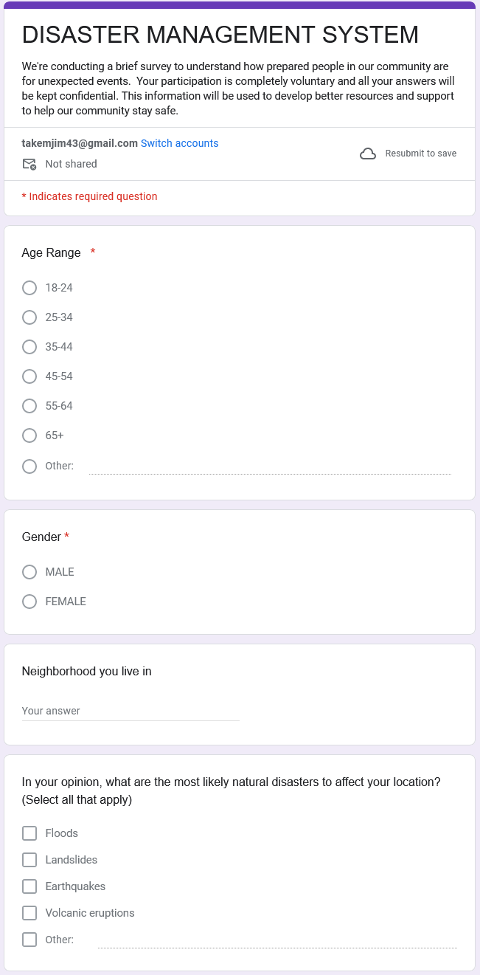 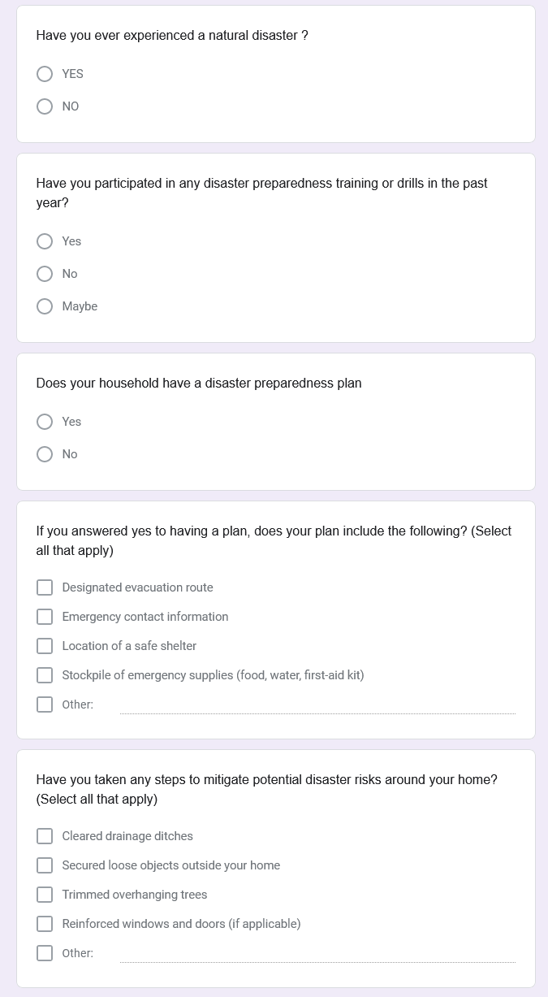

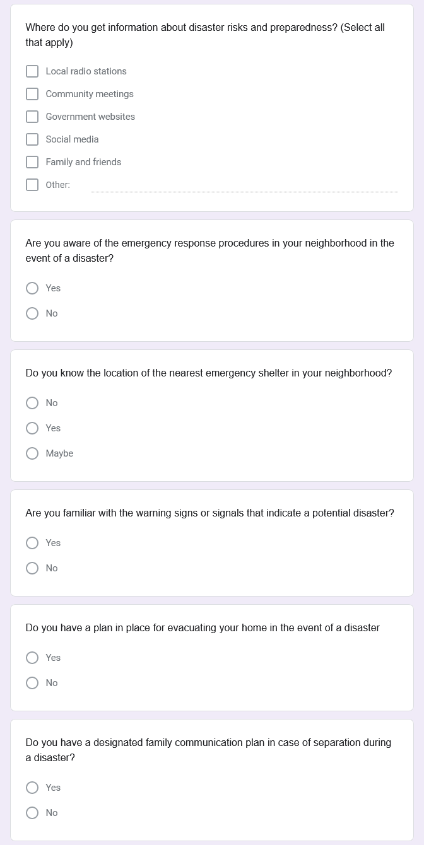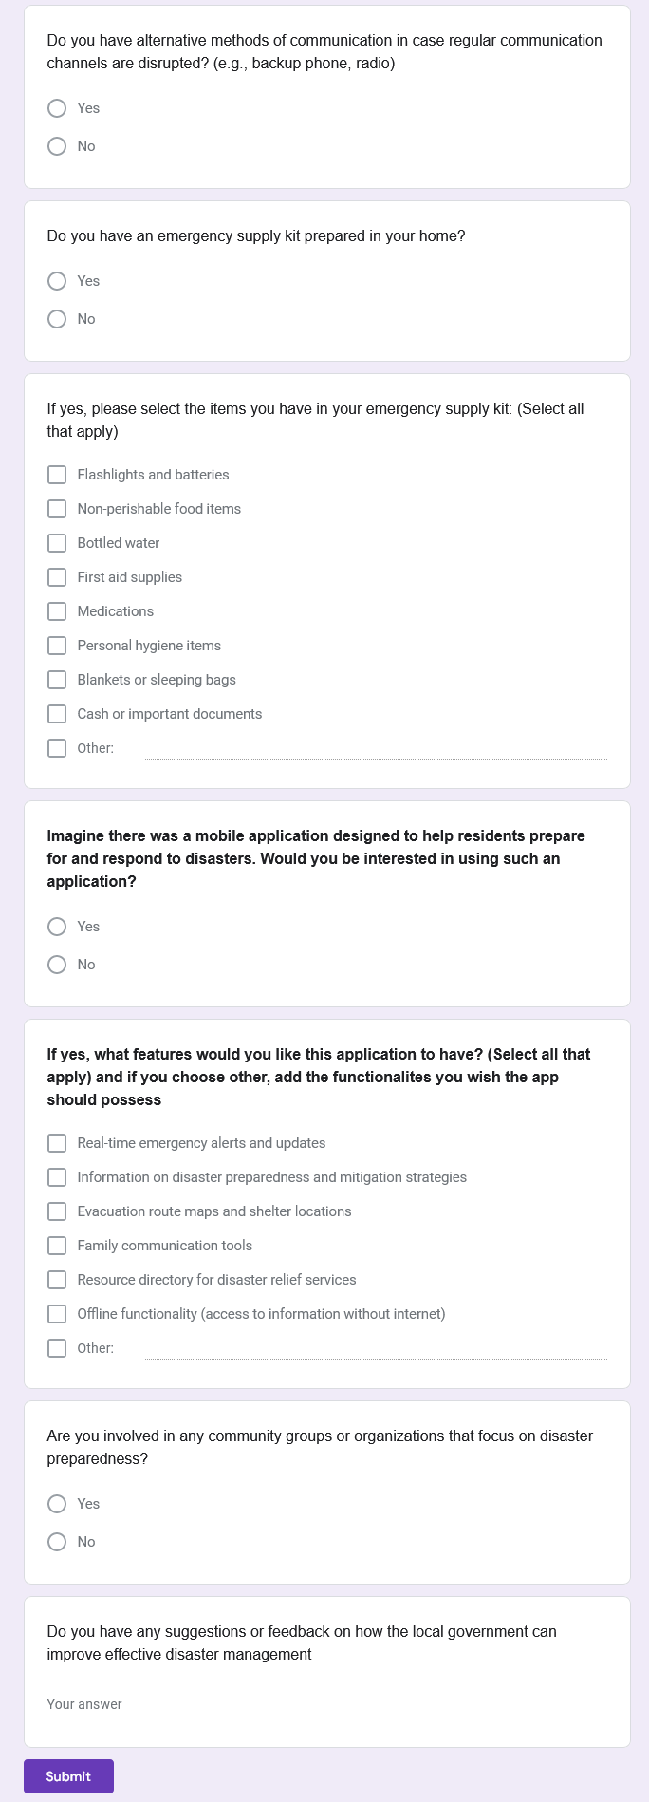

## 4.1.1.2 **Data Collection Process**:

The survey was disseminated through various online channels to reach a broad audience:

* Social media platforms (e.g., Facebook, Twitter, WhatsApp etc.) relevant to the community
* Community websites and online bulletin boards

## 4.1.1.3 **Sample Size and Demographics**:

The survey aimed for a diverse sample to represent the entire community. While we cannot pinpoint exact demographics until data analysis, the distribution methods were chosen to encourage participation from all age groups and backgrounds. (Raw data was collected for approximately 20 people through the pre-testing phase).

## 4.1.1.4 **Data Security and Confidentiality**:

The survey was designed anonymously, and no personal identifying information was collected. All responses will be kept confidential and used solely for the purpose of improving community disaster preparedness resources.

## 4.1.2 **Citizen Interviews**

Citizen interviews provided an opportunity to gain detailed insights and personal perspectives from residents.

* **Interview Format:** Semi-structured interviews allowed for flexibility to explore topics in more depth based on the resident's responses.
* **Sample Selection:** A purposive sampling approach was used to ensure a diverse group of participants representing different age groups, neighborhoods, and backgrounds potentially impacted by disasters (approximately 30 – 40 participants.
* **Interview Topics:** The interview guide covered topics such as:
  + Disaster awareness and concerns
  + Existing preparedness measures taken at home and within the community
  + Information sources and preferred communication channels during disasters
  + Perceptions of community preparedness efforts
  + Suggestions for improvement

## 4.1.2.1 **Data Collection Process**:

Interviews were conducted in-person at a mutually convenient location or remotely via our popular social media platforms e.g. WhatsApp, Facebook etc. Informed consent was obtained from all participants before the interview began.

## 4.1.2.2 **Data Security and Confidentiality**:

All interviews were conducted confidentially. Participants were informed that their responses would be anonymized in the final report.

## 4.1.3 **Document Review**

We conducted a review of existing documents relevant to community preparedness to gather data and gain historical context and insights from past experiences. Here are some examples of documents reviewed, though the specific documents will vary depending on your community:

* **Local emergency response plans:**

<https://floodready.vermont.gov/update_plans/local_emergency_operations>

<https://www2.gov.bc.ca/assets/gov/public-safety-and-emergency-services/emergency-preparedness-response-recovery/local-government/em_planning_guide_for_la_fn.pdf>

<https://www.alertmedia.com/blog/emergency-response-plan/>

* **Incident reports from previous disasters:** <https://ourworldindata.org/grapher/natural-disasters-by-type>
* **Community risk assessments:**

<https://rb.gy/8gge9t>

<https://riskassessment.strategicfire.org/wp-content/uploads/2016/03/Community-Risk-Assessment-Guide-v1.5.pdf>

<https://dipecholac.net/docs/files/Community%20Risk%20Assessment%20Training%20Module%20Malawi.pdf>

* **Public awareness campaigns on disaster preparedness:** <https://rb.gy/r28tce>, <https://rb.gy/lt0s9y>

Document review helped identify:

* Existing resources
* Potential vulnerabilities documented in past incidents
* Gaps in current preparedness initiatives

## 4.1.3.1 **Data Collection Process**:

Existing documents were collected from relevant local government agencies, emergency response organizations, and community archives.

## 4.1.3.2 **Sample Size and Demographics**:

This section is not applicable to document review, as the focus is on the content of the documents themselves.

## 4.1.3.3 **Data Security and Confidentiality**:

All documents were handled securely and in accordance with data privacy regulations.

# BUSINESS REQUIREMENTS

The business requirements define the high-level goals, objectives, and needs that the system is intended to fulfill. Business requirements describe why a project is needed, whom it will benefit, when and where it will take place, andwhat standards will be used to evaluate it.

Business requirements typically focus on the "why" behind the software project, rather than the specific "what" or "how" of the system's functionality. They provide the overarching purpose and rationale for developing the software. The business requirements for this project include:

**5.1** Comprehensive Disaster Management Lifecycle Support

* + The system shall provide an integrated platform to support all stages of the disaster management lifecycle, including preparedness, response, recovery, and mitigation.
  + The system shall offer a range of functionalities and features tailored to the needs of individual users, emergency responders, and other relevant stakeholders.
  1. Real-Time Alerting and Notification
  + The system shall incorporate a real-time alerting and notification system to disseminate critical information to users during emergencies.
  + Alerts shall be customized based on users' geographic locations and preferences, providing timely warnings about impending disasters, evacuation orders, and other relevant information.

5.3 Incident Reporting and Coordinated Response

* + The system shall allow users to report incidents and request assistance directly through the mobile application.
  + The system shall facilitate coordination between emergency responders, volunteers, and affected communities, enabling efficient allocation of resources and timely response to emerging needs.

**5.4** Geospatial Mapping and Situational Awareness

* + The system shall integrate with geospatial data and mapping services to provide users with interactive maps displaying real-time information about disaster-affected areas, evacuation routes, shelter locations, and other relevant spatial data.
  + The system shall enhance situational awareness and support informed decision-making for emergency management personnel.

**5.**5 Community Engagement and Collaboration

* + The system shall include features to promote community engagement and collaboration, such as forums, chat rooms, and social media integration.
  + These tools shall facilitate information sharing, peer support, and collective action among users and stakeholders involved in disaster response and recovery efforts.

5.6 Compliance and Security

* + The system shall comply with all relevant industry standards, regulations, and best practices for emergency management systems.
  + The system shall implement robust security measures to protect sensitive data and ensure the integrity of the system.
  + The system shall adhere to data privacy guidelines and regulations to safeguard the personal information of affected individuals.

# FUNCTIONAL REQUIREMENTS

Functional requirements of a system, in simple terms, are the specific tasks and features that the system needs to perform to meet the needs of its users. They define what the system is supposed to do and how it should behave under certain conditions.

The functional requirements of our disaster management system are listed below:

* 1. User Registration and Authentication: The application should allow users to register and create an account. It should support secure authentication mechanisms to protect user’s personal data like email, password, name etc.
  2. Real-Time Alerts and Notifications: The application should incorporate a system to send real-time alerts and notifications to users about impending disasters, evacuation orders, and other relevant information. These alerts should be customizable based on users’ geographic locations and preferences.
  3. Incident Reporting: Users should be able to report incidents and request assistance directly through the mobile application. The system should support different types of incident reports, including text, photos, and videos.
  4. Emergency Resource Access: The application should provide access to emergency resources such as first aid guides, emergency contact numbers, and safety tips.
  5. Communication with Authorities: The application should facilitate communication between users and authorities. This could include features like direct messaging, emergency calls, and request tracking.
  6. Geospatial Data Integration: The application should integrate with geospatial data and mapping services to provide users with interactive maps displaying real-time information about disaster-affected areas, evacuation routes, shelter locations, and other relevant spatial data.
  7. Community Engagement Features: The application should include features to promote community engagement and collaboration, such as forums, chat rooms, and social media integration. These tools should facilitate information sharing, peer support, and collective action among users and stakeholders involved in disaster response and recovery efforts. The application to should also permit users with resources to become emergency volunteers.
  8. Data Privacy and Security: The application should ensure the privacy and security of user data. This includes complying with relevant data protection regulations and implementing appropriate security measures.
  9. Offline Functionality: Considering that disasters can disrupt internet connectivity, the application should provide essential features in offline mode, such as viewing downloaded emergency guides or maps.
  10. Multilingual Support: To ensure the application is usable by a diverse range of users, it should support multiple languages.
  11. User Feedback and Support: The application should provide mechanisms for users to give feedback and get support. This could include a help center, FAQ section, and customer support contact.

# NON-FUNCTIONAL REQUIREMENTS

To ensure the effectiveness of our disaster management system, several non-functional requirements are crucial. These non-functional requirements address how the system should perform or behave rather than what specific features it offers.

* 1. Usability: The system should be easy to use without prior experience or training, for people with varying technical skills and should support multiple languages.
  2. Performance: The app should function with minimal delays, even in areas with low network connectivity.
  3. Security: User data and system information must be protected against cyberattacks and unauthorized access.

**7.4** Reliability: The system must consistently function during emergencies with minimal delays and downtime, providing accurate and up-to-date information.

* 1. Scalability: The system should be able to handle a large influx of users concurrently during disasters.
  2. Maintainability: The system should be easy to update and maintain over time to adapt to changing technologies and disaster risks.
  3. Accessibility: The system should be accessible for people with disabilities, including features for visually impaired and hearing-impaired users.

# REQUIREMENTS DOCUMENTATION

Requirements documentation refers to the written document that captures and defines the requirements for a software system or product. It serves as the foundation for the entire software development process and is a crucial artifact in any software project. Documenting the requirements in a clear and structured manner is essential for communication and traceability. The requirements documentation serves as a communication tool between the stakeholders (e.g., customers, users, product owners) and the development team. Not only will this documentation be helpful at the end of the project when you reflect back on goals achieved, updates accomplished, features added and bugs fixed, but it will also act to help manage stakeholder expectations, and keep team members focused and on track. The requirements documentation typically includes the following key elements:

* Review Existing Documentation
* Identify Stakeholders
* Business Requirements
* Gather Functional Requirements
* Non-Functional Requirements…

This report acts as our requirements document as it defines the essential business and functional requirements for the development of the Mobile-Based Disaster Management System. The requirements document ensures the final product meets the goals, addresses the stakeholders' needs, and provides a solid foundation for the design and development of the system. It will serve as the foundation for the development team, allowing them to build a system that meets the specified criteria and can be updated later if stakeholder needs are changed.

# MANAGING REQUIREMENT CHANGES

Given the dynamic nature of disaster management requirements and the potential for evolving stakeholder needs, a process needs to be put in place to manage the changes to the documented requirements. This change management process will ensure the disaster management system remains aligned with evolving stakeholder needs and stay responsive, relevant, and effective over time.

9.1 Change Request Submission: Once a change request is approved, the project team will update the requirements documentation accordingly, including the requirement descriptions, user stories, traceability matrix, and any other relevant artifacts.

The versioning system will be used to track the changes and maintain a clear history of the requirement evolution.

9.2 Communication and Dissemination: The project team will communicate the approved changes to all relevant stakeholders, including development teams, users, and external partners.

This will ensure that everyone involved in the disaster management system is aware of the updates and can adjust their plans and processes accordingly.

9.3 Ongoing Monitoring and Evaluation: The project team will continuously monitor the implementation and effectiveness of the changed requirements, gathering feedback from users and stakeholders.

This feedback will be used to further refine the requirements and inform future change requests, ensuring the disaster management system remains optimized and responsive to evolving needs.

# REFERENCES

1. <https://en.unesco.org/disaster-risk-reduction>
2. <https://www.preventionweb.net/>
3. <https://www.projectmanager.com/blog/requirements-gathering-guide>
4. <https://floodready.vermont.gov/update_plans/local_emergency_operations>
5. <https://www2.gov.bc.ca/assets/gov/public-safety-and-emergency-services/emergency-preparedness-response-recovery/local-government/em_planning_guide_for_la_fn.pdf>
6. <https://www.alertmedia.com/blog/emergency-response-plan/>
7. <https://ourworldindata.org/grapher/natural-disasters-by-type>
8. <https://rb.gy/8gge9t>
9. <https://riskassessment.strategicfire.org/wp-content/uploads/2016/03/Community-Risk-Assessment-Guide-v1.5.pdf>
10. <https://dipecholac.net/docs/files/Community%20Risk%20Assessment%20Training%20Module%20Malawi.pdf>
11. <https://rb.gy/r28tce>, <https://rb.gy/lt0s9y>